Test Case: tc001_SPX_Dev5_Crear_Requisicion_Spot_Tipo_Cobro_CC
Step 1 - Enter username and password and click to button Enter : Credentials Entered
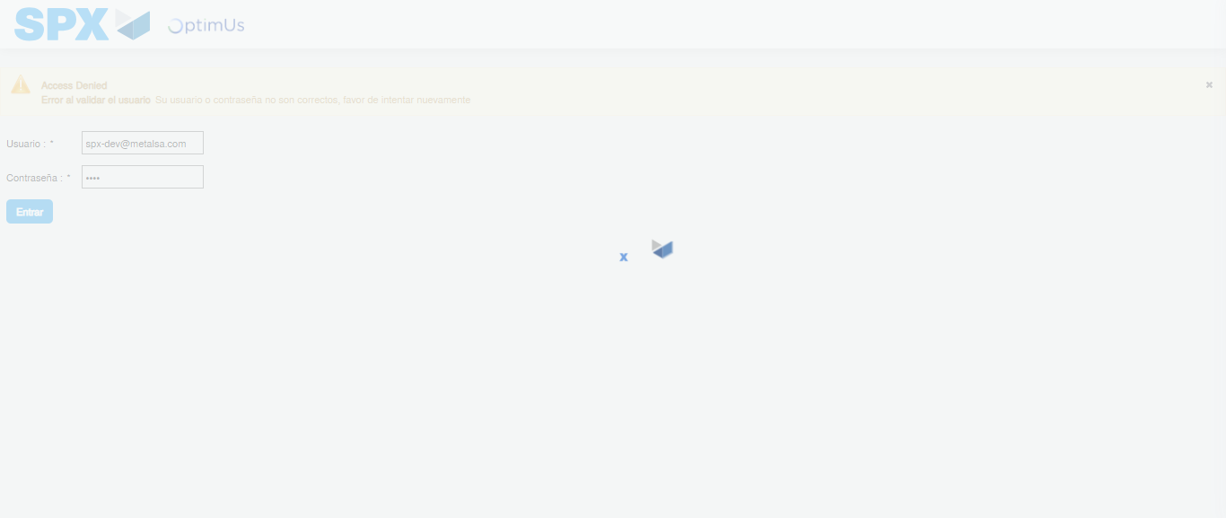Image file-name: QC_Testing-tc001_SPX_Dev5_Crear_Requisicion_Spot_Tipo_Cobro_CC-1783984290611

Step 2 - Select to UEN and Access to Spot Buy Requisitions : UEN Correctly selected and Correct access
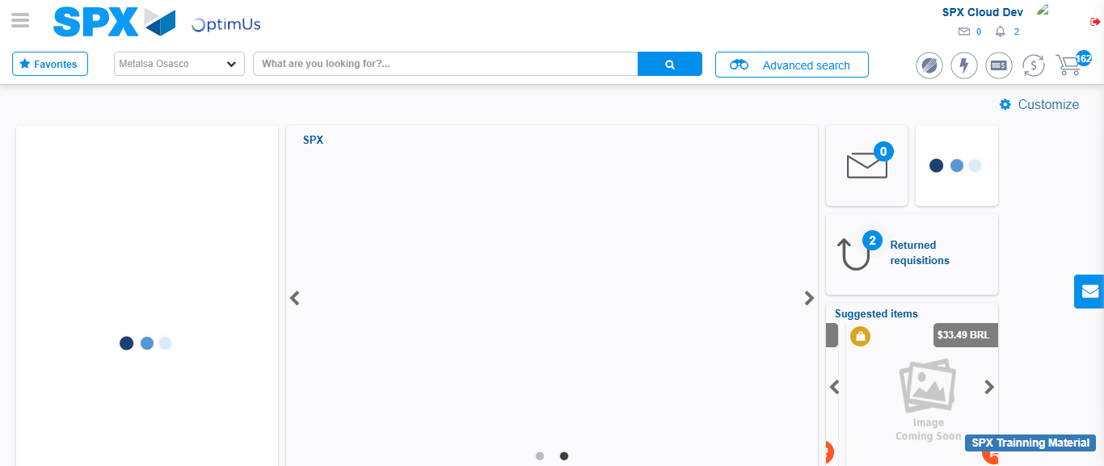Image file-name: QC_Testing-tc001_SPX_Dev5_Crear_Requisicion_Spot_Tipo_Cobro_CC-1783984316782

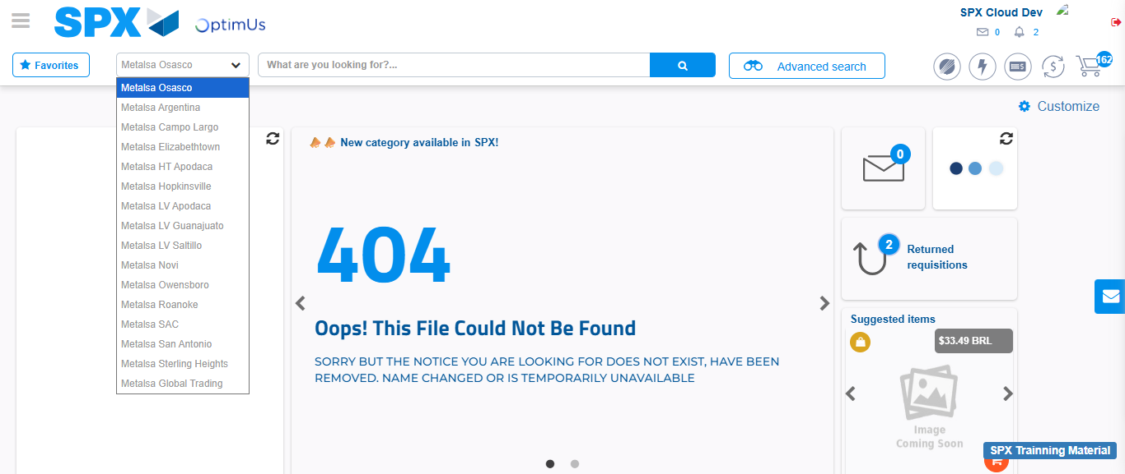Image file-name: QC_Testing-tc001_SPX_Dev5_Crear_Requisicion_Spot_Tipo_Cobro_CC-1783984319371

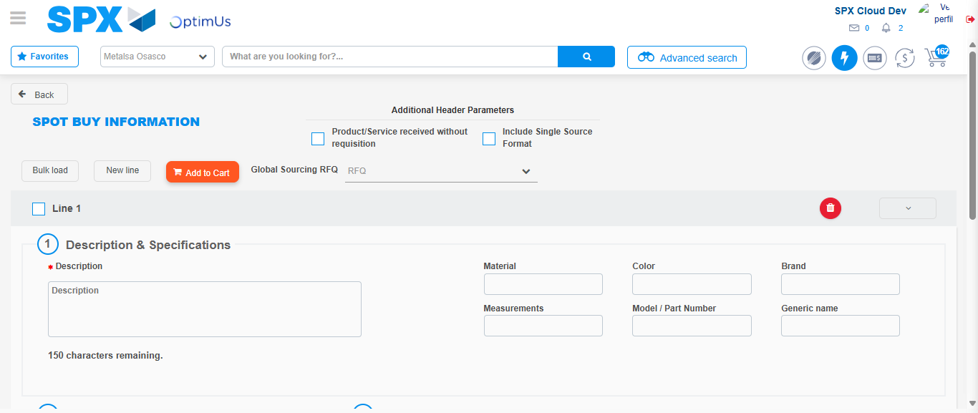Image file-name: QC_Testing-tc001_SPX_Dev5_Crear_Requisicion_Spot_Tipo_Cobro_CC-1783984339462

Step 3 - Data Capture Spot Buy Requisition : Data captured correctly
Image file-name: QC_Testing-tc001_SPX_Dev5_Crear_Requisicion_Spot_Tipo_Cobro_CC-1783984339756

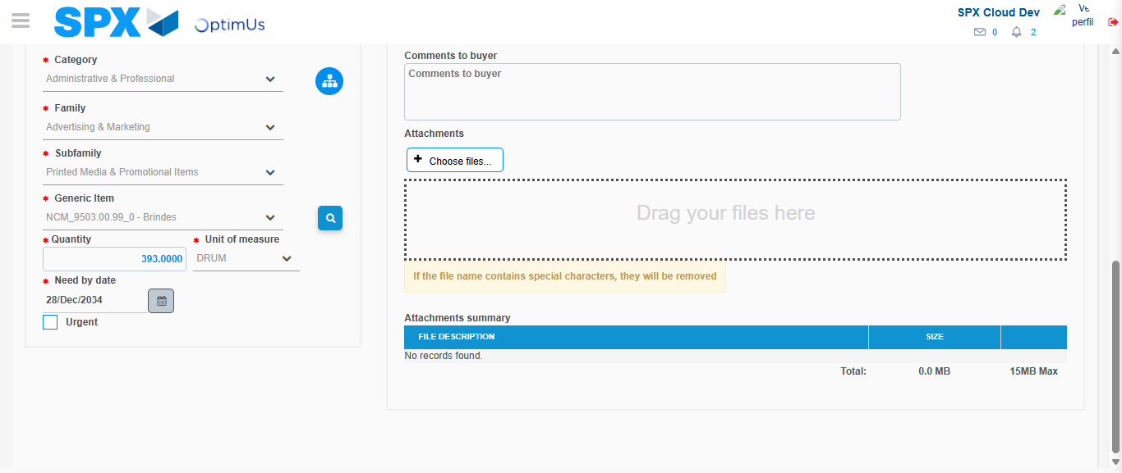Image file-name: QC_Testing-tc001_SPX_Dev5_Crear_Requisicion_Spot_Tipo_Cobro_CC-1783984351631

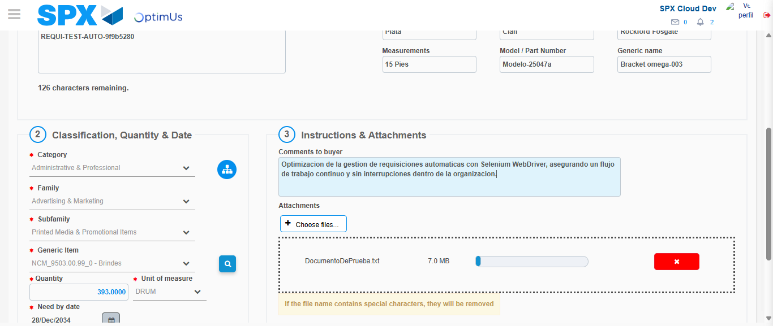Image file-name: QC_Testing-tc001_SPX_Dev5_Crear_Requisicion_Spot_Tipo_Cobro_CC-1783984352411

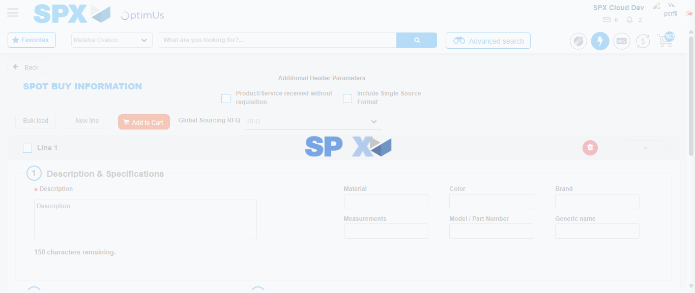Image file-name: QC_Testing-tc001_SPX_Dev5_Crear_Requisicion_Spot_Tipo_Cobro_CC-1783984366471

Step 7 - Return to Main Page SPX : Return to Main Page SPX
Image file-name: QC_Testing-tc001_SPX_Dev5_Crear_Requisicion_Spot_Tipo_Cobro_CC-1783984316782

Image file-name: QC_Testing-tc001_SPX_Dev5_Crear_Requisicion_Spot_Tipo_Cobro_CC-1783984319371

Image file-name: QC_Testing-tc001_SPX_Dev5_Crear_Requisicion_Spot_Tipo_Cobro_CC-1783984339462

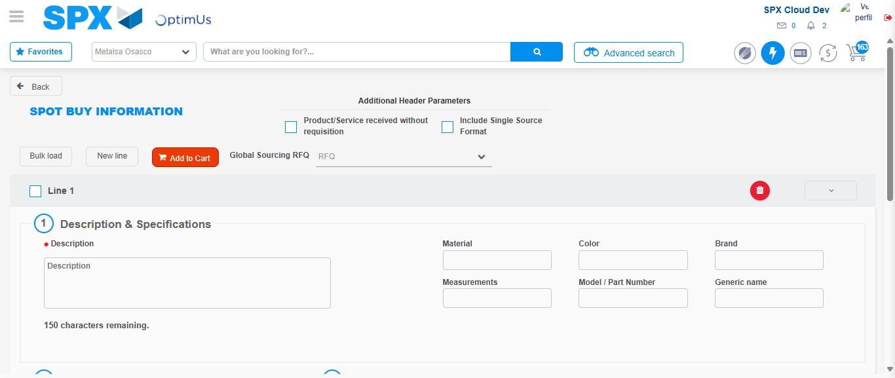Image file-name: QC_Testing-tc001_SPX_Dev5_Crear_Requisicion_Spot_Tipo_Cobro_CC-1783984368732

Image file-name: QC_Testing-tc001_SPX_Dev5_Crear_Requisicion_Spot_Tipo_Cobro_CC-1783984368914

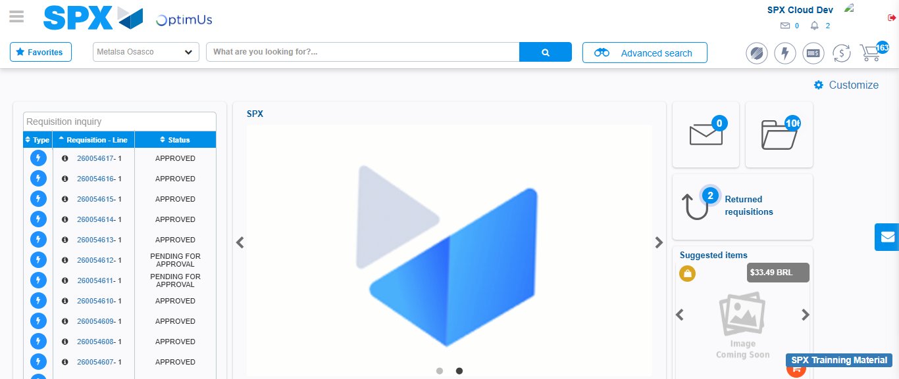Image file-name: QC_Testing-tc001_SPX_Dev5_Crear_Requisicion_Spot_Tipo_Cobro_CC-1783984389911

Step 8 - Log Out : Log Out SPX
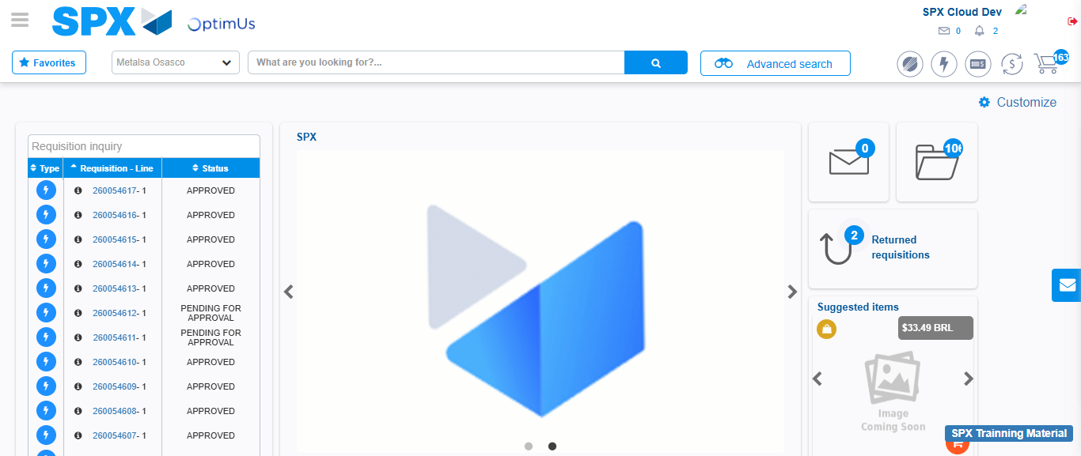Image file-name: QC_Testing-tc001_SPX_Dev5_Crear_Requisicion_Spot_Tipo_Cobro_CC-1783984390220

